FY19 Intro to Databricks Hack – Proctor Guide
  - Introduction to using Spark on Azure Databricks

Goals
Most challenges observed by customers in these realms are in stitching multiple services together. As such, where possible, we have tried to place key concepts in the context of a broader example.

Once all hackathon challenges are completed, you should be able to:
- Create an Azure Databricks cluster
- Create Azure Databricks workspace and notebook for data exploration
- Understand the difference between Spark 1 and Spark 2 (RDD API vs. Dataframe API)
- How to use Spark SQL API to wrangle datasets using a familiar syntax

Background Knowledge
This hackathon is meant for data engineers & data scientists on Azure. Previous experience with the following may be helpful but is not required:
  - Spark
  - Azure HD Insight
  - Python
  - Jupyter notebooks

Introduction

In this challenge, you will provision a Databricks workspace and a Spark cluster. You will then use the Spark
cluster to explore data interactively.

Getting Started:
To complete the challenges, you will need the following:
• A web browser
• A Microsoft account
• A Microsoft Azure subscription
• A Windows, Linux, or Mac OS X computer
• Azure Storage Explorer
• The challenge files for this course

Note: To set up the required environment for the challenge, follow the instructions in the Setup document for
this course. Specifically, you must have signed up for an Azure subscription.

Provisioning Azure Resources
Note: If you already have an Azure Databricks Spark cluster and an Azure blob storage account, you can
skip this section.

Provision a Databricks Workspace
1. In a web browser, navigate to http://portal.azure.com, and if prompted, sign in using the
Microsoft account that is associated with your Azure subscription.
2. In the Microsoft Azure portal, click  Create a resource. Then in the Analytics section select
Azure Databricks and create a new Azure Databricks workspace with the following settings:
• Workspace name: Enter a unique name (and make a note of it!)
• Subscription: Select your Azure subscription
• Resource Group: Create a new resource group with a unique name (and make a note of
it!)
• Location: Choose any available data center location.
• Pricing Tier: Standard
3. In the Azure portal, view Notifications to verify that deployment has started. Then wait for the
workspace to be deployed (this can take few minutes)

Provision a Storage Account
1. In the Azure portal tab in your browser, and click  Create a resource.
2. In the Storage category, click Storage account.
3. Create a new storage account with the following settings:
• Name: Specify a unique name (and make a note of it)
• Deployment model: Resource manager
• Account kind: Storage (general purpose v1)
• Location: Choose the same location as your Databricks workspace
• Replication: Locally-redundant storage (LRD)
• Performance: Standard
• Secure transfer required: Disabled
• Subscription: Choose your Azure subscription
• Resource group: Choose the existing resource group for your Databricks workspace
• Virtual networks: Disabled
4. Wait for the resource to be deployed. Then view the newly deployed storage account.
5. In the blade for your storage account, click Blobs.
6. In the Browse blobs blade, click  Container, and create a new container with the following
settings:
• Name: spark
• Public access level: Private (no anonymous access)
7. In the Settings section of the blade for your blob store, click Access keys and note the Storage
account name and key1 values on this blade – you will need these in the next procedure.

Create a Spark Cluster
1. In the Azure portal, browse to the Databricks workspace you created earlier, and click Launch
Workspace to open it in a new browser tab.
2. In the Azure Databricks workspace home page, under New, click Cluster.
3. In the Create Cluster page, create a new cluster with the following settings:
• Cluster Mode: Standard
• Cluster Name: Enter a unique cluster name (and make a note of it)
• Databricks Runtime Version: Choose the latest available version
• Python Version: 3
• Driver Type: Same as worker
• Worker Type: Leave the default type
• Min Workers: 1
• Max Workers: 2
• Auto Termination: Terminate after 60 minutes.
• Spark Config: Add two key-value pairs for your storage account and key like this:
fs.azure.account.key.your_storage_account.blob.core.windows.net your_key1_value
spark.hadoop.fs.azure.account.key.your_storage_account.blob.core.windows.net your_key1_value
Note: The first setting enables code using the newer Dataframe-based API to access your
storage account. The second setting is used by the older RDD-based API.
4. Wait for the cluster to be created.

Challenge 1 (details for proctor only / not for attendees – see end of document for what attendees will see):
Exploring Data Interactively with Spark RDDs
Now that you have provisioned a Spark cluster, you can use it to analyze data. In this exercise, you will
use Spark Resilient Distributed Datasets (RDDs) to load and explore data. The RDD-based API is an
original component of Spark, and has largely been superseded by a newer Dataframe-based API;
however, there are many production systems (and code examples on the Web) that use RDDs, so it’s
worth starting your exploration of Spark there.
Upload Source Data to Azure Storage
In this exercise, you will use the Spark RDD API to explore unstructured data. Before you can do this, you
must store the data files you want to explore in a blob storage container where it can be accessed by
your cluster. The instructions here assume you will use Azure Storage Explorer to do this, but you can
use any Azure Storage tool you prefer.

1. In the folder where you extracted the challenge files for this course on your local computer, in the data
folder, verify that the KennedyInaugural.txt file exist. This file contains the data you will explore
in this exercise.
2. Start Azure Storage Explorer, and if you are not already signed in, sign into your Azure
subscription.
3. Expand your storage account and the Blob Containers folder, and then double-click the spark
blob container you created previously.
4. In the Upload drop-down list, click Upload Files. Then upload KennedyInaugural.txt as a block
blob to a new folder named data in root of the spark container.

Create a Notebook
Most interactive data analysis in Databricks is conducted using notebooks. These browser-based
interactive documents enable you to combine notes in Markdown format with code that you can run
right in the notebook – with no requirement to install a local code editing environment. In this exercise,
you can choose to write your code using Python or Scala.

1. In the Databricks workspace, click Workspace. Then click Users, click your user name, and in the
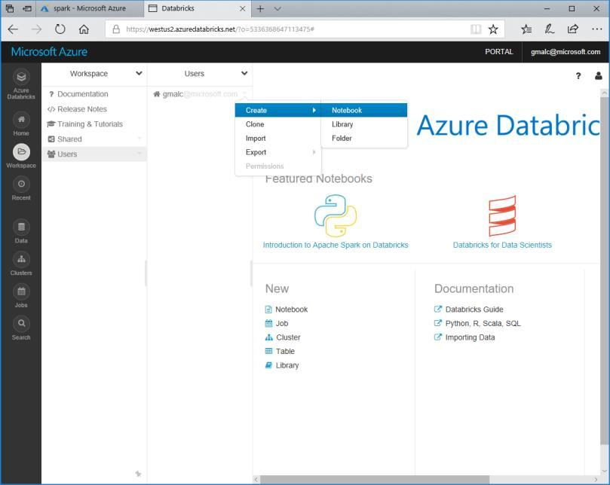
drop-down menu for your username point click Create and Notebook as shown here:

2. Create a new notebook with the following settings:
• Name: RDDs
• Language: Choose Python or Scala as preferred.
• Cluster: Your cluster
3. In the new notebook, in the first cell, enter the following code to enter some Markdown text:
%md
# Kennedy Inauguration
This notebook contains code to analyze President Kennedy’s inauguration speech.
4. Click anywhere in the notebook outside of the first cell to see the formatted markdown, which
should look like this:
Kennedy Inauguration
This notebook contains code to analyze President Kennedy’s inauguration speech.
5. Hold the mouse pointer under the center of the bottom edge of the cell until a (+) symbol is
displayed; then click this to insert a new cell.
6. In the new cell, type the following code, replacing <account> with the fully qualified name of
your Azure Storage account (account_name.blob.core.windows.net):
Python
txt = sc.textFile("wasbs://spark@<account>/data/KennedyInaugural.txt")
txt.count()
Scala
val txt = sc.textFile("wasbs://spark@<account>/data/KennedyInaugural.txt")
txt.count()

In this code, the variable sc is the Spark context for your cluster; which is created automatically
within the notebook.

7. With the code cell selected, at the top left of the cell, click the  button and then click  Run
Cell to run the cell. After a few seconds, the code will run and display the number of lines of text
in the text file as Out[1]
8. Add a new cell and enter the following command to view the first line in the text file.
Python
txt.first()
Scala
txt.first()

9. Run the new cell and note that the first line of the speech is displayed as Out[2].
10. Add a new cell and enter the following command to create a new RDD named filtTxt that filters
the txt RDD so that only lines containing the word “freedom” are included, and counts the
filtered lines.
Python
filtTxt = txt.filter(lambda line: "freedom" in line)
filtTxt.count()

Scala
val filtTxt = txt.filter(line => line.contains("freedom"))
filtTxt.count()
11. Run the new cell and note that the number of lines containing “freedom” is returned as Out[3].

12. Add a new cell and enter the following command to display the contents of the filtTxt RDD.
Python
filtTxt.collect()
Scala
filtTxt.collect()
13. Run the new cell and note that the lines containing “freedom” are returned as Out[4].
14. Add a new cell and enter the following command to split the full speech into words, count the
number of times each word occurs, and display the counted words in descending order of
frequency.
Python
words = txt.flatMap(lambda txt: txt.split(" "))
counts = words.map(lambda word: (word, 1)).reduceByKey(lambda a, b: a + b)
counts.sortBy(lambda a: a[1], False).collect()
Scala
val words = txt.flatMap(line => line.split(" "))
val counts = words.map(word => (word, 1)).reduceByKey((a, b) => a + b)
counts.sortBy(_._2,false).collect().foreach(println)
15. Run the new cell and review the output, which shows the frequency of each word in the speech
in descending order.

Exploring Data Interactively with Dataframes
Spark 2.0 and later provides a schematized object for manipulating and querying data – the DataFrame.
This provides a much more intuitive, and better performing, API for working with structured data. In
addition to the native Dataframe API, Spark SQL enables you to use SQL semantics to create and query
tables based on Dataframes.

Upload Source Data to Azure Storage
In this challenge, you will explore both structured data relating to road traffic accidents. Before you can do
this, you must upload the data files containing the data to your blob storage container where it can be
accessed by your cluster. The instructions here assume you will use Azure Storage Explorer to do this,
but you can use any Azure Storage tool you prefer.

1. In the folder where you extracted the challenge files for this course on your local computer, in the data folder, verify that the Accidents.csv and Vehicles.csv files exist. These files contain the data you
will explore in this exercise.
2. Start Azure Storage Explorer, and if you are not already signed in, sign into your Azure
subscription.
3. Expand your storage account and the Blob Containers folder, and then double-click the spark
blob container you created previously in this challenge.
4. In the Upload drop-down list, click Upload Files. Then upload Accidents.csv and Vehicles.csv as
block blobs to the data folder in root of the spark container that you created previously in this
challenge.

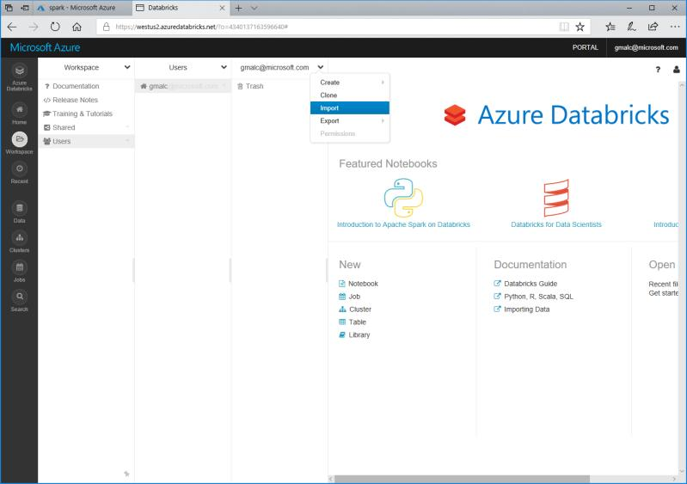
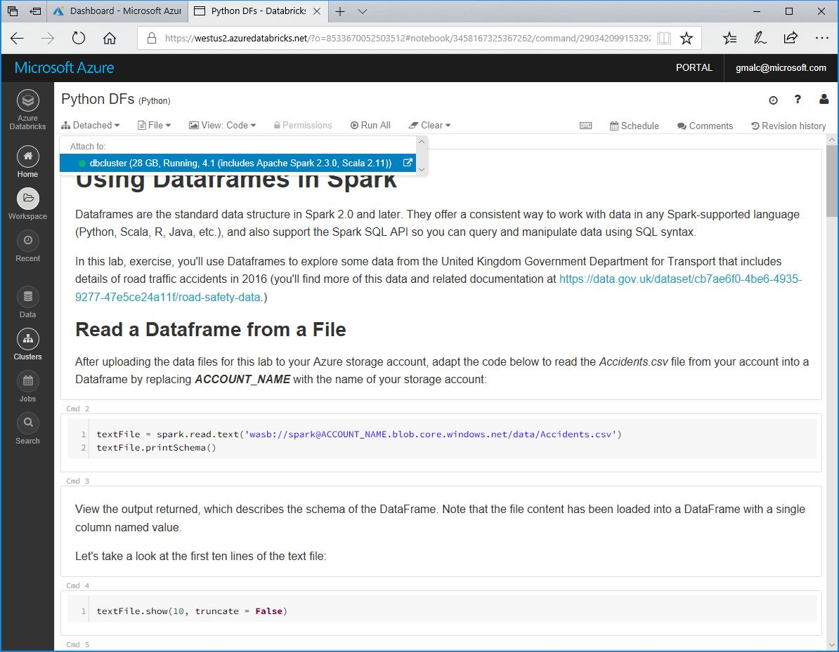

Work with Dataframes
In this procedure, you will use your choice of Python or Scala to query the road traffic accident data
in the comma-delimited text files you have uploaded. Notebooks containing the necessary steps to
explore the data have been provided.
1. In the Databricks workspace, click Workspace. Then click Users, click your user name, and in the
drop-down menu for your username click Import as shown here:

2. Browse to the folder where you extracted the challenge files. Then select either Dataframes.ipynb or
Dataframes.scala, depending on your preferred choice of language (Python or Scala), and
upload it.
3. Open the notebook you uploaded and in the Detached drop-down menu, attach the notebook
to your Spark cluster as shown here:

4. Read the notes and run the code cells to explore the data.

Clean Up
Note: If you intend to proceed straight to the next challenge, skip this section. Otherwise, follow the steps
below to delete your Azure resources and avoid being charged for them when you are not using them.

Delete the Resource Group
1. Close the browser tab containing the databricks workspace if it is open.
2. In the Azure portal, view your Resource groups and select the resource group you created for
your databricks workspace. This resource group contains your databricks workspace and your
storage account.
3. In the blade for your resource group, click Delete. When prompted to confirm the deletion,
enter the resource group name and click Delete.
4. Wait for a notification that your resource group has been deleted.
5. After a few minutes, a second resource group containing the resources for your cluster will
automatically be deleted.
6. Close the browser.

Challenge 2: Creating a Spark Job
Spark jobs enable you to run data processing code on-demand or at scheduled intervals. This enables
you to build data processing solutions for unattended execution.
Upload Source Data to Azure Storage
In this exercise, you will create a Spark job to process a web server log file. Before you can do this, you
must store the log file you want to process in a blob storage container where it can be accessed by your
cluster. The instructions here assume you will use Azure Storage Explorer to do this, but you can use any
Azure Storage tool you prefer.
1. In the folder where you extracted the challenge files for this course on your local computer, in the data
folder, verify that the IISlog.txt file exist. This file contains the data you will process in this
exercise.
2. Open IISlog.txt in a text editor and view its contents. It contains details of page requests made
to a website, including requests to a page named products.aspx for which a query string
indicates the specific product that the user is viewing. Close the file without saving any changes.
3. Start Azure Storage Explorer, and if you are not already signed in, sign into your Azure
subscription.
4. Expand your storage account and the Blob Containers folder, and then double-click the spark
blob container you created previously.
5. In the Upload drop-down list, click Upload Files. Then upload IISlog.txt as a block blob to a
folder named data in root of the spark container.



Upload Code to Process the Data
In this challenge, you will use your choice of a Python or Scala script to process the web server log data you
have uploaded. Source files containing the necessary code to process the data have been provided.
1. In the Databricks workspace, click Workspace. Then click Users, click your user name, and in the
drop-down menu for your username click Import as shown here:

2. Browse to the folder where you extracted the challenge files. Then select either ProcessLog.py or
ProcessLog.scala, depending on your preferred choice of language (Python or Scala), and upload
it.
3. Open the file you uploaded to view the code it contains, read the comments to understand what
it does, and change both instances of <YOUR_ACCOUNT> to the name of your Azure Storage
account.

Create a Job to Run the Code
Now that you’ve uploaded the code, you’re ready to automate its execution with a job.
1. In the Databricks workspace, click Jobs. Then click Create Job.
2. Name the new job Process Web Log.
3. For the Task option, click Select Notebook and select the ProcessLog code file you
uploaded previously.
4. For the Parameters option, Click Edit and add the following key-value pair:

logfile
Note that these values are case-sensitive.
IISlog.txt

5. For the Cluster option, click Edit and configure the cluster for the job as follows:
 Cluster Type: New Cluster
 Databricks Runtime Version: Choose the latest available version
 Python Version: 3
 Driver Type: Same as worker
 Worker Type: Leave the default type
 Workers: 1
 Spark Config: Add a key-value pair for your storage account and key like this:
fs.azure.account.key.your_storage_account.blob.core.windows.net your_access_key1_value

6. For the Schedule option, click Edit and note that you can schedule the job to run at regular
intervals. Then cancel the edits to the schedule and leave it set to None.
7. Under Active runs, click Run Now to start the job.

View Job Status and Output
Now that you’ve started the job, you can observe its status and view the output.
1. In the Databricks workspace, click Jobs. Note that the Process Web Log job is listed with a
green  icon to indicate it is active.
2. Click the Process Web Log job. This returns you to the job details page where Run 1 should
be listed under Active runs.
3. Note the Status value for Run 1. Initially this will be Pending. Over time it will change to
Running, and then to Succeeded. After it has succeeded, Run 1 will be moved to the
Completed in the last 60 days list.
4. Click Run 1 to view the job output. This includes the code that was executed, and the output
returned by the Spark process that ran the code.
5. In the Databricks workspace, click Clusters, and in the Job Clusters list, note that a new
cluster was created for the job and is now in a Terminated state.
View the Processed Data
Now that you’ve run the job, you can view the processed data.
1. Use your preferred Azure storage tool to view the contents of the spark container in your
Azure storage account. This should contain a new folder named output that was created by
your job code.
2. In the output folder, view the files that have been generated by the job. These include:
 _committed_nnnn (a checkpoint file written when the output was committed)
 _started_nnnn (a checkpoint file written when the job started)
 _SUCCESS (a file indicating the result status of the job)
 Part-00000-nnn csv (the output data produced by the job)
3. Download and view the Part-00000-nnnn .csv file to view the output generated by the job. This file contains the number of web page views for each product.
Challenge 3: Process a Stream of Data
Spark structured streaming enables you to use the dataframe API to read and process an unbounded
stream of data. This kind of processing is used in real-time scenarios to aggregate data over temporal
intervals or windows. You can use Spark to process streaming data from a wide range of sources,
including zure Event Hubs, Kafka, and others. In this challenge, you’ll process data as it is added to a folder in
Azure blob storage.
Upload Initial Data to Azure Storage
In this exercise, you will process a stream of data that simulates status information generated by
Internet-of-things (IoT) devices. The data will be written to a blob storage container where it can be
accessed by your Spark cluster. The instructions here assume you will use Azure Storage Explorer to
upload the data, but you can use any Azure Storage tool you prefer.

1. In the folder where you extracted the challenge files for this course on your local computer, verify that
the data\stream folder contains four files named stream_N.txt. These files contain simulated
status data from hypothetical IoT devices.
2. Start Azure Storage Explorer, and if you are not already signed in, sign into your Azure
subscription.
3. Expand your storage account and the Blob Containers folder, and then double-click the spark
blob container you created previously.
4. In the Upload drop-down list, click Upload Files. Then upload only stream_1.txt as a block blob
to a new folder named stream in root of the spark container.

Upload Code to Process the Data Stream
In this challenge, you will use your choice of a Python or Scala script to process the streaming IoT data.
Source files containing the necessary code to process the data have been provided.
1. In the Databricks workspace, click Workspace. Then click Users, click your user name, and in the
drop-down menu for your username click Import as shown here:

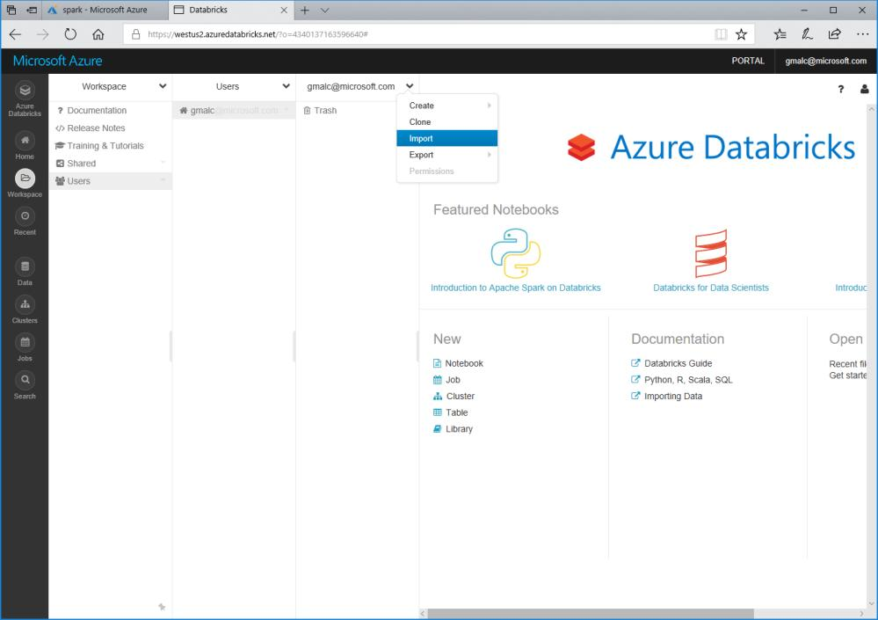
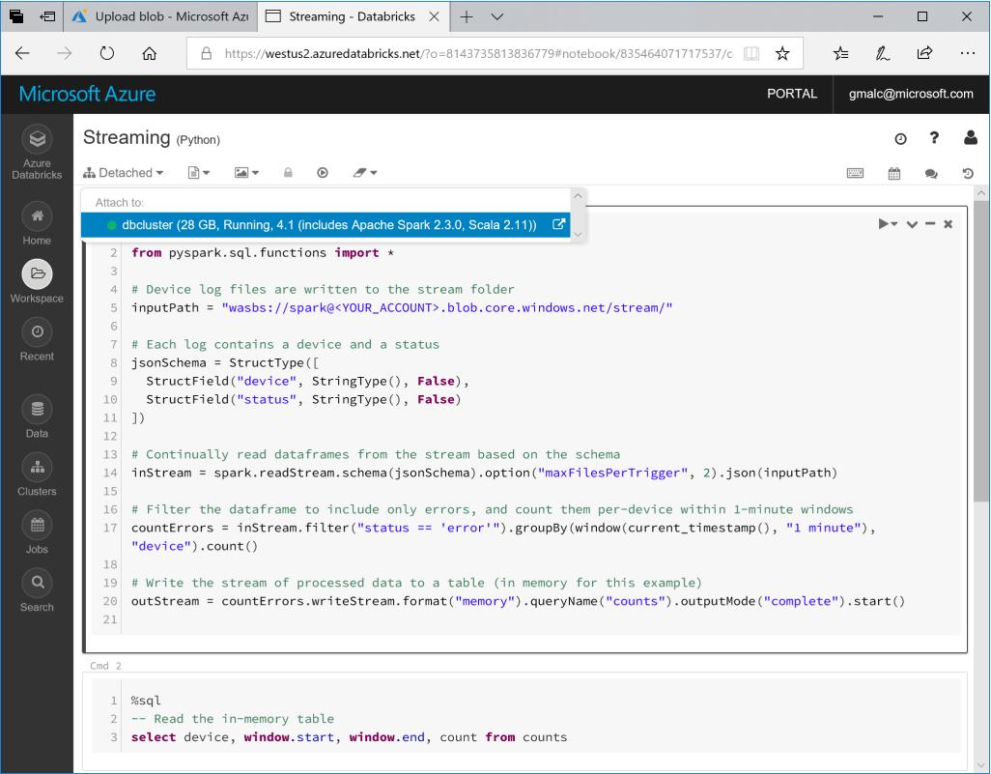

2. Browse to the folder where you extracted the challenge files. Then select either Streaming.py or
Streaming.scala, depending on your preferred choice of language (Python or Scala), and upload
it.
3. Open the file you uploaded to view the code it contains, and read the comments to understand
what it does.
4. Open the notebook you uploaded and in the Detached drop-down menu, attach the notebook
to your Spark cluster as shown here:

Process the Streaming Data
Now that you’ve uploaded the stream processing code, you’re ready to use it to capture real-time
device status and aggregate it over temporal windows.
1. In the Streaming notebook, modify the first cell to replace YOUR_ACCOUNT with the name
of your Azure storage account. The run the cell to start a streaming context and continually
read data from the stream folder.
2. Wait for the stream to initialize and the counts streaming query to be created and then run
the code in the second cell, which queries the in-memory table of streaming data. If there are
no results, wait for a few seconds and try again.
3. While the stream processing code is still running, use your preferred Azure Storage tool to
upload the stream_2.txt file to the stream folder in your spark blob container.
4. Return to the notebook and run the second cell again to verify that the new data added to
the folder is included in the stream.
5. Wait 30 seconds or so and then repeat the previous two steps to upload stream_3.txt and
stream_4.txt; running the second cell in the notebook after each upload to see the new data
in the stream.

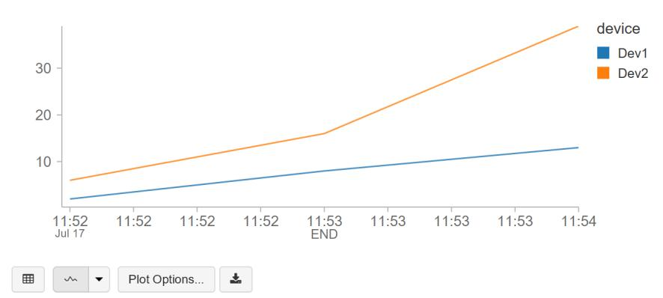

Visualize the Data
Your streaming query is now continually capturing data as files are added to the blob storage
location, and aggregating the data values over 1-minute windows. You can plot this data to see
trends in the data over time.
1. Under the table of device error data, in the plot drop-down list. click Line to plot the data as
a line chart.
2. Click Plot Options and configure the following settings:
• Keys: End
• Series groupings: Device
• Values: Count
• Aggregation: Sum
The plot should now show the total errors for each device as counted at the end of each
1-minute window, like this:

Stop the Streaming Query
When you are finished capturing data, you can stop the streaming query.
1. Run the code in the third code cell to stop the query.

Challenge 4: Introduction to Spark for Machine Learning

Background:
Spark includes an API named Spark MLLib (often referred to as Spark ML), which you can use to create machine learning solutions. Machine learning is a technique in which you train a predictive model using a large volume of data so that when new data is submitted to the model it can predict unknown values. The most common types of machine learning are supervised learning and unsupervised learning.

Machine Learning Terminology:
In a supervised learning scenario, you start with labels that are known & data that also includes features (categorical and numeric values that describe characteristics of the entity you’re trying to predict something about). Training the model involves applying a statistical algorithm that fits the features to the labels. Because your initial data includes known values for the labels, you can train the model and test its accuracy with these known label values – giving you confidence that the model will work accurately with new data for which the label values aren’t known.

Unsupervised learning is a technique in which there are no known label values, and the model is trained to group (or cluster) similar entities together based on their features.

Challenge considerations:

In this challenge, we’ll focus on supervised learning and specifically a type of machine learning called classification in which you train a model to identify which category, or class an entity belongs to.

Challenge 4.1) Creating and Testing A Machine Learning Model

Upload Source Data to Azure Storage
In this challenge, you will train a classifier to use features of flights that are enroute to an airport, and predict
whether they will be late or on-time. Before you can do this, you must upload the data file containing
the data to your blob storage container where it can be accessed by your cluster. The instructions here
assume you will use Azure Storage Explorer to do this, but you can use any Azure Storage tool you
prefer.

1. In the folder where you extracted the challenge files for this course on your local computer, in the data
folder, verify that the raw-flight-data.csv files exists. This file contain historic flight data you will
use to train a classification model that predicts whether a flight will be late or not.
2. Start Azure Storage Explorer, and if you are not already signed in, sign into your Azure
subscription.
3. Expand your storage account and the Blob Containers folder, and then double-click the spark
blob container you created previously in this challenge.
4. In the Upload drop-down list, click Upload Files. Then upload raw-flight-data.csv as a block blob
to the data folder in root of the spark container that you created previously.

Train a Machine Learning Model
In this procedure, you will use your choice of Python or Scala to prepare and explore the flight data,
before training and testing a classification model.
1. In the Databricks workspace, click Workspace. Then click Users, click your user name, and in the

drop-down menu for your username click Import as shown here:

1. Browse to the folder where you extracted the challenge files. Then select either Machine
Learning.ipynb or Machine Learning.scala, depending on your preferred choice of language
(Python or Scala), and upload it.
2. Open the file you uploaded to view the code it contains, read the comments to understand what
it does, and change <YOUR_ACCOUNT> to the name of your Azure Storage account in the first
code cell.
3. Read the notes and run the code cells to explore the data.

Clean Up
Note: This is the final challenge in this course. If you have finished exploring Spark, follow the steps below to
delete your Azure resources and avoid being charged for them when you are not using them.

Delete the Resource Group
1. Close the browser tab containing the databricks workspace if it is open.
2. In the Azure portal, view your Resource groups and select the resource group you created for
your databricks workspace. This resource group contains your databricks workspace and your
storage account.
3. In the blade for your resource group, click Delete. When prompted to confirm the deletion,
enter the resource group name and click Delete.
4. Wait for a notification that your resource group has been deleted.
5. After a few minutes, a second resource group containing the resources for your cluster will
automatically be deleted.
6. Close the browser.

Working together
- Will your team work together or individually?
- Git for Windows – allows for working with Git repos locally on your machine as well as in VSTS. https://gitscm.com/downloads
- Determine Azure Subscription you will use for deployment

Resources
There are several folders in the Team site, including resources folders for each challenge.

Challenges (attendee view) : Got Data? Use Spark in Azure Databricks

Challenge 1: Intro to Spark
This challenge involves loading textual data in Azure blob storage (for this exercise, we will be using President Kennedy’s inaugural speech as our content source) and will use Spark - either python or scala (your choice) - to filter and transform the dataset according to the challenge summary.
Challenge Summary
Your team is preparing a proof of concept, and your group has been tasked to suggest answers to the following questions:

1. Can you determine the intent of President Kennedy’s speech <hint: look for words like freedom & create filtered views for those keywords to answer the question>
2. Are there any additional Spark concepts that you would use to help bring value to your analysis?
3. What are some potential ways you could save time during your analysis <hint: less lines of code following one API approach vs. another means faster time to value>
4. Are there any notable differences when analyzing Unstructured vs. Structured datasets?

Document your suggestions on the teams site or other whiteboards/flipcharts provided. You will present your results.
Business Case Ia – Unstructured Analysis using President Kennedy’s Speech – <need to add link here>
- Setup assistance & Introduction to Azure Databricks concept <See 1_Setup.md in the Team site > - includes setting up Azure Blob Storage for data files that will be consumed during challenges

- Challenge 1.1: Setting up Azure Databricks: Create a cluster
- Challenge 1.2: Setting up Azure Databricks: Create a workspace & your first notebook
- Challenge 1.3: Use RDD API (python or scala) to transform unstructured data file from Azure Blob Storage

Business Case Ib – Structured Analysis of Traffic Accidents – <need to add link here>

- Challenge 1.4: Setting up Azure Databricks: Create new notebook & label it Dataframes.ipynb
- Challenge 1.5: Use Dataframes API (python or scale) (Spark 2.0) to analyze new STRUCTURED datasets (related to traffic accidents) : Read data in from Azure Blob storage
- Challenge 1.6: Create dataframes to analyze traffic patterns & vehicle densities by location;
- Challenge 1.7: Create top and bottom views of accident data to better under emerging patterns <if they exist>
- Challenge 1.8: Transform existing dataframes into Temporary Tables or Permanent Tables if your query results are deemed meaningful by your table using Spark SQL API

Follow up Activities:
- Discuss approaches and analysis with Table
- Load your Q&A and Feedback on your Teams site

Got Data? Use Spark in Azure Databricks

Challenge 2: Running a Spark Job

What You’ll Need
To complete the challenges, you will need the following:
• A web browser
• A Microsoft account
• A Microsoft Azure subscription
• A Windows, Linux, or Mac OS X computer
• Azure Storage Explorer
• The challenge files for this course <only if you get stuck – proctors have access to this content>

Note: To set up the required environment for the challenge, follow the instructions in the Setup document for
this course. Specifically, you must have signed up for an Azure subscription.

Challenge Background: Spark jobs enable you to run data processing code on-demand or at scheduled intervals. This enables you to build data processing solutions for unattended execution.

Business Challenge: your business has asked you to analyze voluminous web server logs

Questions:
- What types of analyses would be good when working with website log data ? Remember, you want to provide value to the business quickly.
- If you look at the ProcessLog.py files, what Spark modules are being used and why do you think they were chosen? Would you have chosen alternate modules and why?
- What else would you add to the script to enhance what it is already doing using what you learned in Challenge 1?
- Can you explain the purpose of the different files that were created by the Spark job process in your blob storage?
- What is the file name(s) created that contains the Processed Results? Does it contain the # of webpage views for each product that you were expecting?

To get you started, the 1st thing you will need to do is to Import your ProcessLog.py or .scala script into your Databricks Workspace. How? Ask your table mates.

** remember: you can use scala or python; you can use Databricks notebooks or native scripts (.py, for example) to solve the Challenge **

***Lastly. If you get stuck, proctors can help you without providing the answer.
Challenge 2 Outline:

Challenge 2.1) Access Databricks Workspace from Challenge 1 or Provision a New Databricks Workspace if you didn’t complete Challenge 1

Challenge 2.2) Access existing Storage Account & Create a new Container for Challenge 2 (if you didn’t complete Challenge 1, create a new Storage Account / Container)
helpful tips:
**Upload the log source files - These logs have been made available as part of the Teams site under Files <IISLog.txt>

Challenge 2.3) Create Spark Job in Azure Databricks
helpful tips:
** you will need to import the ProcessLog.py or ProcessLog.scala file from Teams to your Databricks Workspace (file found in Teams files)

**you will need to edit the scripts with your storage account details – also, add other transformers or use different modules if you want to test out your knowledge or have a different idea for how to approach the challenge – points rewarded for teamwork and for creative thinking!!

Challenge considerations:

- Access your Databricks workspace to create Spark job – Spark jobs can be used to automate execution of your scripts. Spark jobs that are created can be checked into a DevOps CICD pipeline along with artifacts created in your Databricks workspace (eg. Notebooks and other script files).

2. For the Task option, click Select Notebook and choose the ProcessLog code file you
uploaded previously (either .py or .scala)

3. For the Parameters option, enter the following key-value pair <note: values are case sensitive>

logfile
IISlog.txt

4. Cluster settings - , click Create New (this is your jobs cluster):
• Cluster Type: New Cluster
• Databricks Runtime Version: Choose the latest available version
• Python Version: 3
• Driver Type: Same as worker (leave default)
• Workers: 1

- Important setting to append:

• Spark Config: Add a key-value pair for your storage account and key like this:
fs.azure.account.key.your_storage_account.blob.core.windows.net your_access_key1_value

5. For the Schedule option, choose a schedule if you want OR click Run Now to start the job.

6. View job status as it moves from Pending to Running to Succeeded. Notice how Active Runs changes as status change
Challenge 3 Outline:

Challenge 4 Outline:

Working together
- Will your team work together or individually?
- Git for Windows – allows for working with Git repos locally on your machine as well as in VSTS. https://gitscm.com/downloads
- Determine Azure Subscription you will use for deployment

Resources
There are several folders in the Team site, including resources folders for each challenge.

